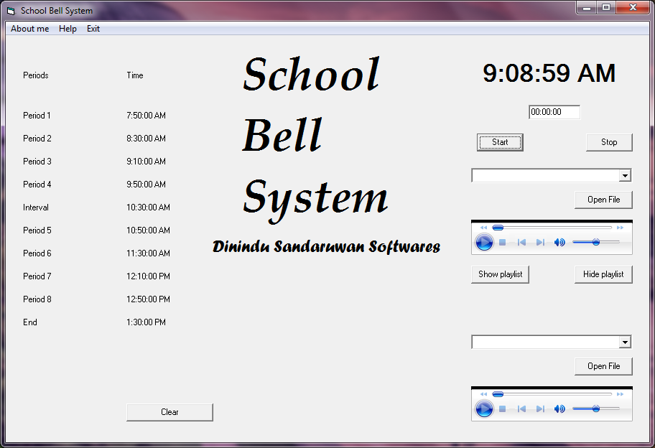

Give the bell tone file path (support files / Audio files/---School Ringing - Sound Effect Bell (1).mp3)



Give Recorded ( announcement) /other audio file path (support files / Audio files/National anthem)